Assignment 2 Game Hardware

Ian Spyksma - 100878511

*Abstract*

This assignment is to show case the development of the game hardware product I have designed. I wanted to help solve the problem of accessibility in first person-shooting games. This is important because many FPS games are very competitive and complex games, making it hard for people with physical disabilities to be on the same playfield as someone who is physically abled. I plan of solving this problem by making a very simple to use and cheap one-handed controller that is easy to learn and used for those who are not able to use a keyboard and mouse or a regular controller. I have found from this assignment that development and designing a good product takes times a lot of time and effort and that everyone has different needs when it comes to problems that need to be addressed.

# Introduction

This assignment has been very interesting and has shown me a lot about what it takes to make a good product that will help more people out then just solving the few issues a small demographic may have. I have been focusing on making a one-handed FPS controller that is easy to use, learn, and is made cheap and effectively. Many controllers made to solve the issue of physically accessibility have been very interesting to see and use. Many using out of the box ideas to try and solve a problem of physically accessibility for people that may only have one working hand. The PlayStation accessibility controller has been a hot topic on the gaming world for its attempt of trying to solve this issue and many people saying it is hard to use and its very comfortable to use. My play was to make a computer mouse-like controller that has everything someone would need to play a FPS game with. The design was very block and big at first but after some tweaks, My design has become more sleek and compact. This allow for a more comfortable and ergonomic design that is comfortable for people to use and still allowing for the functionality of a regular gamepad.

To achieve this goal I used the critical chain project management system. It is to map out all the tasks in branches with time requirement that are needed to complete the task. Doing that allowed for me to find the critical chain, which is the path that will take the most amount of time to complete. Focusing on this main branch allows me to be done on schedule with a completed product. My critical chain for the game hardware overall assignment is properly making a product. Find this, allows me to time manage better and find task that can be done while others are being worked on.

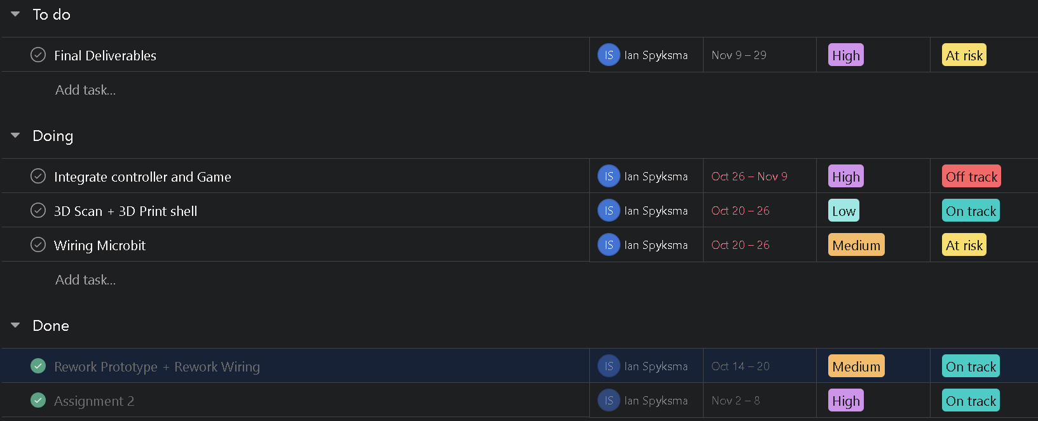

Figure 1 Schdeuling

This is a small example of what My scheduling is looking like.

# Results

**Bill of Materials**

To make this product, materials were needed and some materials have had to be reobtained due to faulty wiring while being made and being broken in transit.

|  |  |  |  |  |  |
| --- | --- | --- | --- | --- | --- |
| BoM level | Description | QTY | Units | Unit Cost | Cost |
| 1 | Micro Bit | 1 | 1 | Free | Free |
| 1 | Bread Board | 1 | 3 | $3.33 | $10 |
| 2 | Buttons | 1 | 6 | $0.50 | $20 (Kit bundle) |
| 2 | Thumb sticks | 1 | 1 | $5 | $20 |
| 2 | Resisters | 1 | 8-10 | $0.05 | $20  (Kit bundle) |
| 3 | Wires | 1 | 6 | $3 | $18 |
| 3 | Motor | 1 | 1 | Free | Free |
| 4 | 3D Shell | 1 | 2 | TBD | TBD |
| 5 | Blackberry track pad | 1 | 1 | $12.62 | $12.62 |

Many of these materials came in a kit that made overall cost lower but break down of cost for individual pieces very hard to do. Free items are from the Micro bit kits that were supplied to students my the school. You will also notice that there is a blackberry track pad in the BoM, this is because before settling on the final product, there was a very large chance of using a track pad in place of the traditional thumb stick. Due to lack of knowledge and experience in controller making and controller programming, the track pad was no longer feasible.

**3D Controller Design**

To solve the problem of accessibility controllers being hard to learn and some what uncomfortable to use, I plan on making an ergonomic mouse that has the functionality of a regular gaming controller. In blender, I made a mock up of the controllers general design.

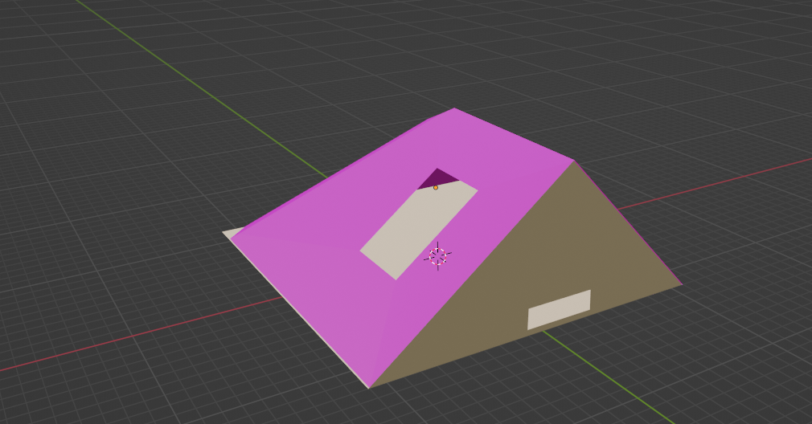

Figure 2 FPS controller model

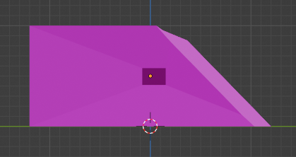

Figure 2.1 Right Side

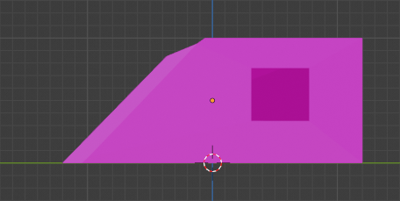

Figure 2.2 Left side

The base dimensions of the controller will be 10cm x 12cm with a peak height of 5cm. It will be made of plastic in 2 parts. O part will be the shell that the user will be holding and the second part will be housing the electrical components. These pieces to make the shell will slide together buy having the and be locked together by latches. This will allow for easy disassembly to for testing and fixing any problems. The second shell will have an access area to plug in the power supply to the controller as seen in Figure 2.3.

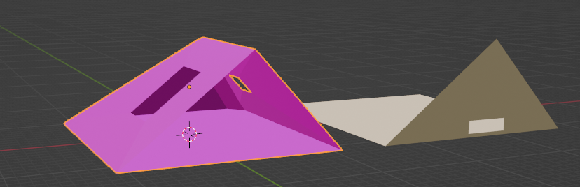

Figure 2.3 Both pieces separate

**3D Prototype**

The design of this controller is to be mouse-like design that is easy to hold with one hand. There will be 6 buttons that are easy to reach with the index, middle, and ring finger. They are spaced out to be comfortably apart and the fingers should be resting on the furthest button from the back side of the controller. There is a Joystick that lies right where the thumb should but is a bit closer to the back to allow for a more comfortable hold and maximum movement of the thumb while using it.

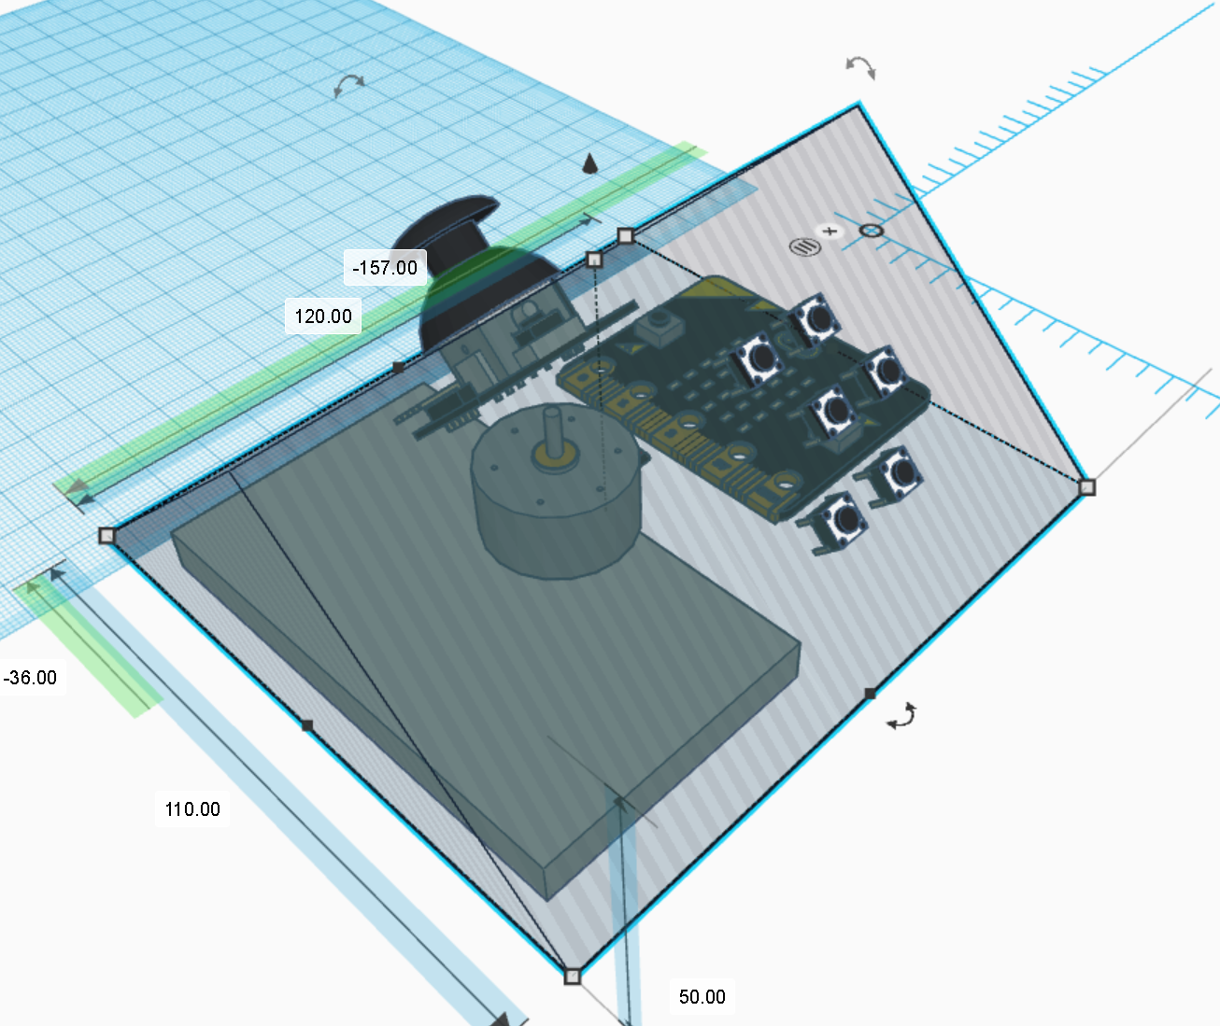

Figure 3 Controller mockup

This is a rough design made in tinkercad to show the materails being used anf how it will be layed out. The hollow tringle is the shell of the controller and will be more erginomic but removing the sharp edges and putting a silicone hand resting spot of the back side of the controller (that being the poit peak on the left side of the picture). The side with the buttons will also be a bit flatter, allowing for amore steep faces for the user to use and help control the controller like a reulare mouse has.

This design also shows the space needed to make this product work, but does not include wiring for the fact that it will take up a fraction of the space needed compared to the other components. On the very bottom of the model, the bread board and mircor it will be kept. This is because they will take up the most amount of space, and with a tappered top and rounded side for the users hand it would be difficult to put them anywhere else. The Thumbstick and Buttons will be pushed out from the controller to allow the user access to them. In the heart of the controller there will be sitting a DC motor. The DC motor will be activated whenever the user desides t o use the shooting functionallity of this controller, giving haptic feedback to the interation.

Cable management is key to a well working product. My cable management plan is to have wires that are only going from one breadboard point to another will be flat and will be as straight as possible to avoid overlap. Wires going to and from the service input devices will have a little slack to allow for easy dissembaly for fixing problems and testing. Th buttons specifically, will be labled between one and six to avoid confusion when ressembling and wires that are connected to the buttons will be individually bundled together to keep them sperate, while also bundling all of the button wires together to keep them contained since they are in the same general area. The motor will have short wires that are connected to the breadboard to allow for some movement, but not enough to unplug itself or other componenets.

**Progress Update**

This project is definitely behind on schedule on where it should currently be. Due to for unforeseen faulty/broken part from poor transport conditions, scheduling with other assignments and classes, and having big events happening in my personal life. For progress made between assignment one and now is the following. I have made a final design that will be made in the coming days. The wiring scheme has been fixed and is in theory going to work with the physical build. All materials and replacement parts are not obtained and are ready for the physical build. The game to showcase the functionality of the controller has been made and is almost completed.

These are the parts that are currently behind and the plan on how to catch them up to the current goal of having a final product by the end of the semester. The physical build has not been fully made or wired and the plan to get that going is to allocate several hours for the next few days to connect everything up. The connection between the controller and the game world is behind because of a lack of a physical component. The plan to fix that is starting the setup of controller inputs while working on making the physical build so when the physical component is ready to test, the game world is ready to use it. The last part that is behind is the lack of a shell to hold the electrical components. The plan for this is to make a general design for the controller (which has already been made) and print on a 3D printer after the wiring and setup for game compatibility so that I can then easily modify it to comfortably hold all the parts while still fitting in the players hand. The changes to the shell would be increasing or decreasing the scale of the design and or add a bit of length to the controller to accommodate a little more room for slack.

# Conclusion

The goal of making a controller to allow people with physical disabilities to play more games comfortably has been a big topic of for the last couple of years. There is a lot of controversy when it comes to what is needed for a accessibility controller. My plan is to make a very simple controller that is meant for one-handed use and allows for the same amount of functionality as a regular controller. My design should fit the requirements of majority of the target clientele by being small, compact, easy to learn and is most of all comfortable to use. I am behind on bring what I have promised for this project, but there is a plan going forward that should bring it all back together to make a product that is functional and good.